**Extent of Dalit Homelessness in Uttar Pradesh**

*Estimation of current Dalit households without housing for the proposed Dalit Awas Yojana*

horizontal line

# Abstract

Estimation is through secondary data. Broadly, 2011 Census data on total SC households is

multiplied by specific sections of housing definition as defined by the Census to estimate the

houseless Dalit households in 2011. For practical purposes this number in itself is sufficient. It

was assumed that the currently completed houses under Indira Awas Yojana & Pradhan Mantri

Awas Yojana would neutralize the rise in population since 2011. Besides, the quality of housing

under these does not meet the standards being considered.

# 

# Selection of Households

This is a two-step process: determining classification of households as Census data and

considering the households which are included in various parts of the definitional basis of Indira

Awas Yojana and Pradhan Mantri Awas Yojana.

## **Housing definitions per Population Census 2011** (Preparation of Layout Map..., 2011)

### 1. INSTITUTIONAL HOUSEHOLD

A group of unrelated persons who live in an institution and take their meals from a

common kitchen is called an Institutional Household. Examples of Institutional

Household are boarding houses, messes, hostels, hotels, rescue homes, jails, ashrams,

orphanages, etc.

### 2. PERMANENT HOUSE

Houses with wall and roof made of permanent materials. Wall can be G. I., Metal,

Asbestos sheets, Burnt bricks, Stone or Concrete. Roof can be made of Tiles, Slate, G. I.,

Metal, Asbestos sheets, Brick, Stone or Concrete.

### 3. SEMI PERMANENT HOUSE

Either wall or roof is made of permanent material (and the other having been made of

temporary material).

### 4. TEMPORARY HOUSE

Houses with wall and roof made of temporary material. Wall can be made of Grass,

Thatch, Bamboo etc., Plastic, Polythene, Mud, Unburnt brick or wood. Roof can be made

of Grass, Thatch, Bamboo, Wood, Mud, Plastic or Polythene.

### 5. UNCLASSIFIABLE

Not classifiable as any of above.

# Indira Awas Yojana housing selection procedure (Implementation of IAY, 2013)

The Indira Awas Yojana suggests careful application of the habitation selection method

which prioritizes providing housing to rural poor as identified by their current housing conditions

in the Socio-Economic Caste Census (SECC-Number of Households Any Member Belonging to

PTG , LRBL , MS (Rural), 2011) and not by BPL cards. However, until the processing of SECC

data, the use of BPL was considered acceptable. This use is now deprecated.

The caste data on break-up of households per census definition are not publicly available.

Therefore, percentage data from census website was utilized with household and population data

from 2011 census as the base of all projections. Instead of using houseless families as per census

2011, however, the vulnerable sections as identified by the SECC were used. The IAY also

considers these sections as primary candidates for state housing programmes. Given the ambition

of providing not just a roof but a roof worthy of living under, semi-permanent houses were

considered for fresh construction instead of reconstruction. Briefly, household types considered:

• Temporary Households (both serviceable and non-serviceable) through

projections from population summary of Population Census, 2011 and percentage

number from SC household and assets table of Population Census, 2011.

• Legally released bonded labour and manual scavengers’ households and directly

reported rural poor as rural poverty of SCs.

• Urban families without households per Population Census, 2011 (as this is a more

reliable number for urban poor from seasonal migration).

• Semi-permanent households through projections from population summary of

Population Census, 2011 and percentage number from SC household and assets

table of Population Census, 2011.

• Unclassifiable per Census, 2011 minus those considered already as houseless.

# Numbers and Results

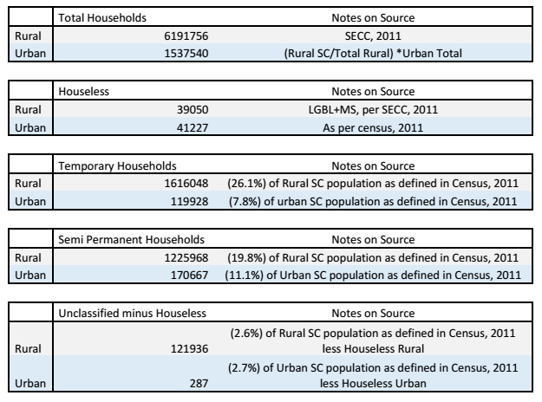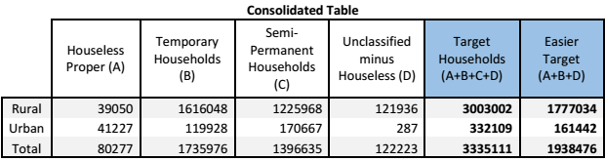

Therefore, we are looking at a target of 30 lacs in rural areas and 3.3 lacs in urban areas

for full upgradation. Under constrained budgeting conditions, the second easier target could be

considered for new construction while semi-permanent houses could be provided partial funding

for improvement.

# References

1. Implementation of IAY. (2013). In Indira Awaas Yojana Guidelines (pp. 13-16). New

Delhi: Ministry of Rural Development.

*2. Preparation of Layout Map... (2011). In Instruction Manual for Houselisting and Housing*

Census (pp. 7-20). Delhi: Office of the Registrar General & Census Commissioner, India.

3. SECC-Number of Households Any Member Belonging to PTG , LRBL , MS (Rural).

(2011). In SECC. New Delhi: Office of The Registrar General and Census Commissioner,

India.